______________’s January Calendar
*Remember, put a on the calendar if you wrote a note in the agenda. That will let me know to look there.
Monday | Tuesday | Wednesday | Thursday | Friday
6  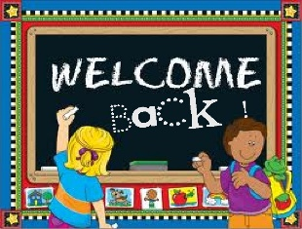          Day 1 | 7      Day 2 | 8        Day 3 | 9             Day 4 | 10  *Snack Cart        Day 5
13              Day 6 | 14   Day 7 | 15                  Day 1 | 16  *Report Cards Sent Home        Day 2 | 17  *Snack Cart  *School Shirt Day              Day 3
20  *NO SCHOOL (MLK Day)      | 21  *Final Round of Yearbook Sales Begin (ends Feb. 7)               Day 4 | 22  *Chess Club Meets After School   Day 5 | 23  *Domino’s Night  *All Clubs Meet After School (except Chess Club)   Day 6 | 24  *Snack Cart  *Wildlife Program      Day 7
27        Day 1 | 28              Day 2 | 29       Day 3 | 30  *PTO Meeting @ 6:00          Day 4 | 31  *Snack Cart  *Dollar Day ($1) – Wear your pajamas to school!  *Bookfair Begins (ends Feb. 11)   Day 5
* Conduct *
Vest
Day 1 PE
Day 2 MUSIC
Day 3 HEALTH
Day 4 LIBRARY
Day 5 ART
Day 6 PE
Day 7 COMPUTER
Note: Every time your child earns an S-, N, or U for the day, TRACK points are accumulated.
If no conduct is recorded, then your child received an “S” for the day!
S- = 1 point N = 2 points U = 3 points
Conduct grades will be based on the number of TRACK points earned:
Progress Reports: 0-5 (S) 6-10 (N) 11+ (U) Report Cards: 0-10 (S) 11-20 (N) 21+ (U)
Langford
Day 1 Computer
Day 2 PE
Day 3 MUSIC
Day 4 HEALTH
Day 5 LIBRARY
Day 6 ART
Day 7 PE

